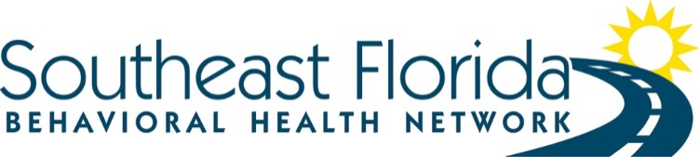
Solicitation# SEFBHN 18/19-003

Notice of Applicants invited to provide an Oral Presentation – Phase II of the evaluation process – refer to Section XV of the RFA
The score noted for each applicant is an average of the scores given by the members of the Applicant Review Team
Team One Applicants:
- Henderson Behavioral Health – Score: 502
Oral Presentation: Wednesday, May 8th, 2019 @ 12:30 PM EST
- Jerome Golden Center – Score: 456
Oral Presentation: Friday, May 10th, 2019 @ 12:30 PM EST
- Psychotherapeutic Services – Score: 372
Oral Presentation: Thursday, May 9th, 2019 @ 3:30 PM EST
Team Two Applicants:
- Psychotherapeutic Services – Score: 372
Oral Presentation: Thursday, May 9th @ 3:30 PM EST
Team Three Applicants:
- Psychotherapeutic Services – Score: 372
Oral Presentation: Thursday, May 9th, 2019 @ 3:30PM EST

